Friday, March 10
Master of Ceremony – CH Brian Chepey

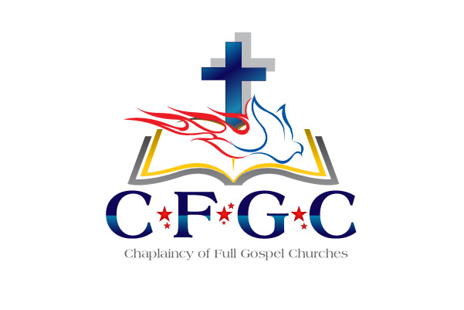
8:00 AM - 9:00 AM Continental Breakfast

9:00 AM - 9:30 AM Praise & Worship
9:30 AM -10:00 AM Devotion – CH Jessie Martinez

10:00 AM -10:15 AM Break

10:15 AM –10:45 AM Organizational Up-Date – Dr. Kitchen

10:45 AM - 11:00 AM Training on Ecclesiastical Standards
and Expectations
CH Brian Chepey, Associate Endorser

11:00 AM -11:30 AM CH Ann Jordan –
Administration Director / Associate Endorser

11:30 AM –12:00 PM Dr. Klon Kitchen

12:00 PM - 4:00 PM Texas BBQ

5:00 PM - 7:00 PM REFLECTION GROUPS

GENERAL ANNOUNCEMENTS:

Dr. Kitchen & CH Chepey will be available for individual conferences (by appointments only on Friday afternoon)
Please reserve time for meeting with them by contacting
CH Ann Jordan @ 972-291-5466 or
at ann.j@cfgc-usa.com)

** Chaplains with administrative issues, please set a time
with CH Jordan or CH Chepey if needing one-on-one time.

PLEASE RETURN NAME BADGES
AT THE END OF OUR TRAINING FOR FUTURE USE. Thank You!
If you desire a Certificate of Attendance for proof of training, please contact Lucille or CH Johnson and we will issue you that Certificate

2023 CFGC Ecclesiastical
Re-Certification & Training
March 6 - 10, 2023
(Schedule subject to change)

Monday March 6
2:00 PM - 5:00 PM Registration – Outside Main Ballroom
7:00 PM – 9:00 PM Movie – The Way

Tuesday March 7

9:00 AM - 1:00 PM Registration – Outside Main Ballroom
9:00 AM - 10:30 AM Prayer for the Training – Associate Endorsers

10:30 AM - 11:00 AM WELCOME - Praise & Worship
11:00 AM - 11:30 AM Devotion – CH Kennie Neal

11:30 AM –11:45 AM Break

11:45 AM – 12:10 PM Dr. Klon Kitchen
Introduce Chaplain Candidates & Vendors

12:10 AM – 12:15 PM CH Gail Porter – Coast Guard Axillary

12:30 PM - 2:00 PM Welcome Luncheon Reception

Each Branch will meet with their Chaplains in
assigned areas for Fellowship & Ministry Specific Updates.

US Army - CH Mark Morgan
US Navy – CH Paul Tremblay
US Air Force – CH Matthew Clouse
VA Chaplains- CH Kim Willis
Hospital/Healthcare/ Hospice Chaplains- CH Anne Jordan
Correctional – CH Carlos Malley
Law Enforcement/Emergency Services – CH Jim Russell
Educational Chaplains – CH Jim Finn
Other Civilian Chaplains – w/ Ch Brian Chepey

2:00 PM – 4:00 PM. Spouses Fellowship - Cheryl Kitchen

4:15 PM Dinner (On your own) & FREE TIME

6:30 PM - Teaching on the Holy Spirit - CH Gary Henry
(Optional)

Wednesday, March 8
Master of Ceremony – CH Brien Harki

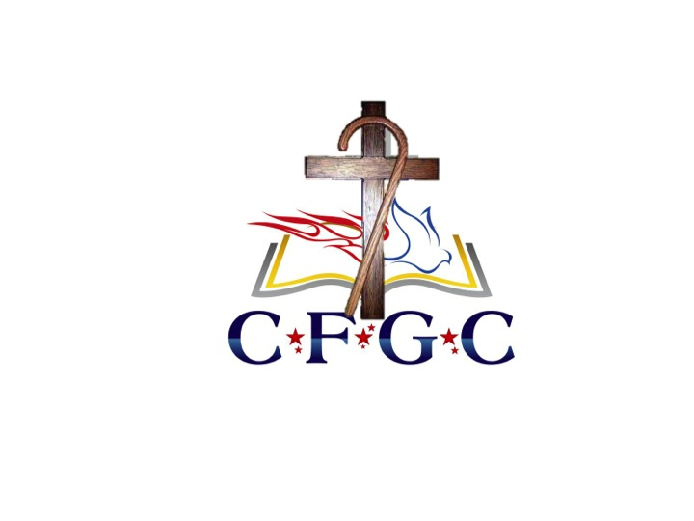
8:00 AM - 9:00 AM Continental Breakfast
9:00 AM - 9:30 AM Praise & Worship
9:30 AM - 10:00 AM Devotion – CH Matt Cassady

10:00 AM - 10:30 AM Break

10:30 AM - 11:15 AM Moral Injury – CH Anne Jordan

11:15 AM - 11:45 AM Break

11:45 AM - 12:30 PM VA Update - CH Kim Willis

12:30 PM - 1:30 PM Lunch

1:30 PM – 2:30 PM Recruiter’s / Vendor’s Up-Dates

3:00 PM – 4:00 PM Mike Berry, Chief of Staff, First Liberty Institute

4:30 AM - 5:30 AM Board of Directors & Chaplains Council
Business Meeting

5:00 PM Dinner (On your own) & FREE TIME

Please make your plans to attend our annual training events again at the Arlington Sheraton, Arlington, Texas

March 4 – 8, 2024
(This will be Dr. & Mrs. Kitchen’s Retirement)

March 3 – 7, 2025

So please join us for this spiritually uplifting
professional development training.

If you are on active duty or in a full-time paid chaplain position
you MUST attend an Annual Training at least
once every three years to remain in good standing
A prayer signup sheet will be located at the main desk
and will be available during the entire conference.

Sign up for a time with
CH Rhonda Harkins for individual times for prayer.

Thursday, March 9
Master of Ceremony – CH Ken Crooks

8:00 AM - 9:00 AM Continental Breakfast
9:00 AM - 9:30 AM Praise & Worship
9:30 AM -10:00 AM Devotion – CH Karen Lomax

10:00 AM -10:30 AM Break
10:30 AM -11:30 AM Preventing Compassion Fatigue (Part 1)
CH Paul Tremblay

11:30 AM –11:45 AM Break

11:45 AM –12:45 PM Preventing Compassion Fatigue (Part 2)
CH Paul Tremblay

12:45 PM - 2:30 PM Lunch

1:15 PM – 3:30 PM Spouses Breakout –

2:30 PM - 3:30 PM Covenant Service (for those being ordained)
OTHERS REFLECTION & FREE TIME

3:00 PM – 5:00 PM Dinner (On your own) & FREE TIME

5:00 PM – 6:00 PM PHOTO SESSION
(Individual/Couple & Group Chaplains w/Spouses)
Military in Formal or Class A Uniform
Civilians – Coat & Tie / Suit/Dress

6:00 PM - Ordination Celebration

Founder’s Award
CH Grant Johnson

Time of Remembrance

Special Recognitions & Retirements

Communion Service

