Friday, March 4

8:00 AM - 9:00 AM Continental Breakfast

9:00 AM - 9:30 AM Praise & Worship
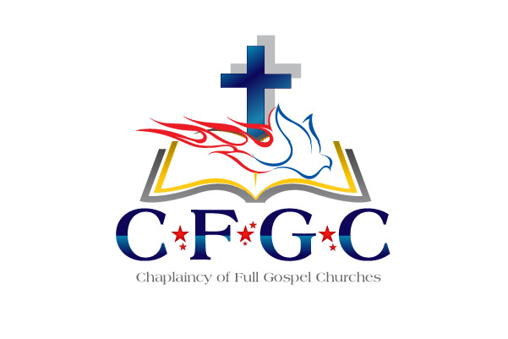
9:30 AM -10:00 AM Devotion – CH Brian Chepey
10:00 AM -10:15 AM Break

10:15 AM –10:45 AM “Please Lord, fill my cup” – Dr. Klon Kitchen

10:45 AM - 11:00 AM Training on Ecclesiastical Standards
and Expectations
Grant Johnson, Associate Endorser

11:00 AM - 11:15 AM Jim Russell- Associate Endorser

11:15 AM -11:30 AM Lucille Singleton – Administration Director
Sherry Dellis – Administrative Assistant

11:30 AM –12:00 PM Dr. Klon Kitchen

12:00 PM - 4:00 PM Texas BBQ

5:00 PM - 7:00 PM REFLECTION GROUPS

GENERAL ANNOUNCEMENTS:

Dr. Kitchen & CH Johnson will be available for individual conferences (by appointments only on Friday afternoon)
Please reserve time for meeting with them by contacting
Ms. Lucille Singleton @ 972-291-5466 or
at lucille.s@cfgc-usa.com)

** Chaplain Candidate’s & Civilian Chaplains please set a time
with CH Johnson if needing one-on-one time.
*** Those with administrative issues, see Ms. Lucille Singleton.

PLEASE RETURN NAME BADGES
AT THE END OF OUR TRAINING FOR FUTURE USE. Thank You!

If you desire a Certificate of Attendance for proof of training, please contact Lucille or CH Johnson and we will issue you that Certificate

2022 CFGC Ecclesiastical
Re-Certification & Training
March 1 - 4, 2022
(Schedule subject to change)

R.O.T.C. Training
(Remaining Obedient To Christ!)

Tuesday March 1

9:00 AM - 10:30 AM Board of Directors & Chaplains Council
Business Meeting
9:00 AM - 1:00 PM Registration – Outside Main Ballroom
9:00 AM - 10:30 AM Prayer for the Training – CH Rhonda Harkins

10:30 AM - 11:00 AM WELCOME - Praise & Worship
11:00 AM - 11:30 AM Devotion – CH Jamison Bowman

11:30 AM –11:45 AM Break

11:45 AM – 1:00 PM Organizational Up-Date – Dr. Kitchen
Dr. Klon Kitchen, Executive Endorsing Agent
Introduce Chaplain Candidates & Vendors

12:30 PM - 2:00 PM Welcome Luncheon Reception
2:00 PM -
Each Branch will meet with their Chaplains in
assigned areas for Fellowship & Ministry Specific Updates.

US Army - CH Mark Morgan
US Navy – CH Paul Tremblay
US Air Force – CH Matthew Clouse
VA Chaplains- CH Matt Cassidy
Hospital/Healthcare Chaplains- CH Donovan Waller
Hospice Chaplains- CH Tatum
Correctional – CH Carlos Malley
Law Enforcement/Emergency Services – CH Jim Russell
Educational Chaplains – CH Jim Finn
Other Civilian Chaplains – w/ CH Grant Johnson
2:00 PM – 4:00 PM. Spouses Fellowship - Cheryl Kitchen

4:15 PM Dinner (On your own) & FREE TIME

6:30 PM - Teaching on the Holy Spirit - CH Gary Henry

(Optional)
Wednesday, March 2

8:00 AM - 9:00 AM Continental Breakfast
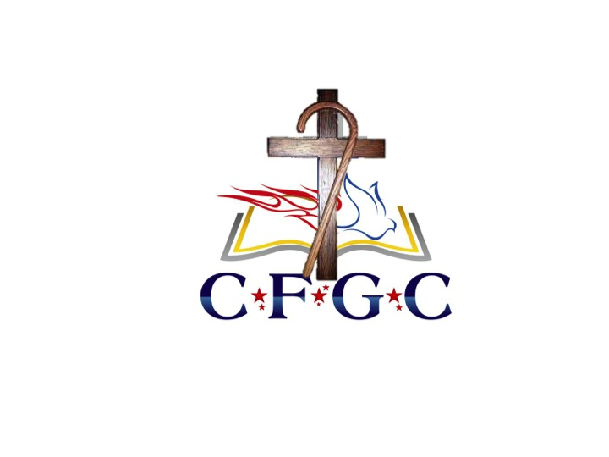
9:00 AM - 9:30 AM Praise & Worship
9:30 AM - 10:00 AM Devotion – CH Meoshia Wilson

10:00 AM - 10:30 AM Break

10:30 AM - 11:15 AM Moral Injury – CH John Morales

11:15 AM - 11:45 AM Break

11:45 AM - 12:30 PM PROVEN – CH Norica Vernon

12:30 PM - 1:30 PM Lunch

1:30 PM – 2:30 PM CH Brent Scott

3:00 PM – 4:00 PM Mike Berry, Chief of Staff, First Liberty Institute

5:00 PM Dinner (On your own) & FREE TIME

Please make your plans to attend our annual training events again at the Arlington Sheraton, Arlington, Texas

March

So please join us for this spiritually uplifting
professional development training.

If you are on active duty or in a full-time paid chaplain position
you MUST attend an Annual Training at least
once every three years to remain in good standing

A prayer table will be located outside the Main Ballroom
and will be available during the entire conference
See CH Rhonda Harkins for individual times for prayer.

Thursday, March 3

8:00 AM - 9:00 AM Continental Breakfast
9:00 AM - 9:30 AM Praise & Worship
9:30 AM -10:00 AM Devotion – CH Larry Jones

10:00 AM -10:30 AM Break
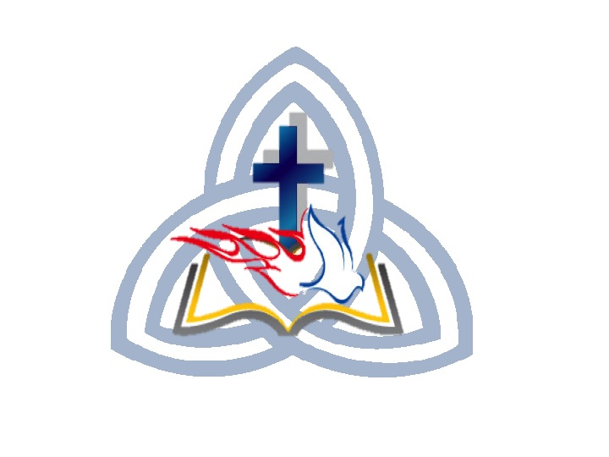
10:30 AM -11:30 AM ???????? – CH Kevin Mateer

11:30 AM –11:45 AM Break

11:45 AM –12:45 PM ???????? – CH Kevin Mateer

12:45 PM - 2:30 PM Lunch

1:15 PM – 3:30 PM Spouses Breakout –

2:30 PM - 3:30 PM Covenant Service (for those being ordained)
OTHERS REFLECTION & FREE TIME

3:00 PM – 5:00 PM Dinner (On your own) & FREE TIME

5:00 PM – 6:00 PM PHOTO SESSION
(Individual/Couple & Group Chaplains w/Spouses)
Military in Formal or Class A Uniform
Civilians – Sports Coat / Suit/Dress

6:00 PM - Ordination Celebration

Presentation of the Founders Award

Special Recognitions & Time of Remembrance

Communion Service

