` Friday, March 6

8:00 AM - 9: 00 AM Continental Breakfast
9:00 AM - 9:30 AM Praise & Worship

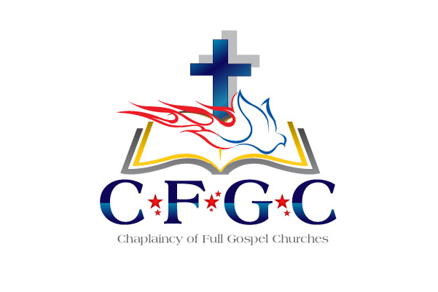
9:30 AM -10:00 AM Devotion – Dr. Jack Lea

10:00 AM -10:30 AM Dr. Klon Kitchen

10:30AM – 10:45 AM Break

10:45 PM - 11:15 PM Training on Ecclesiastical Standards
and Expectations
Grant Johnson, Associate Endorser

11:15 PM -11:45 PM Lucille Singleton – Administration Director
CH. Melinda Ryans – Business Manager& CC Coordinator

12:00 PM - 3:00 PM Texas BBQ

5:00 PM - 7:00 PM REFLECTION GROUPS

GENERAL ANNOUNCEMENTS:

Dr. Kitchen & CH Johnson
will be available for individual conferences
(by appointments only on Friday afternoon)

Please reserve time for meeting with them by contacting
Ms. Lucille Singleton @ 214-331-4373 or
at lucille.s@cfgc-usa.com)

** Chaplain Candidate’s & Civilian Chaplains please set a time
with CH Johnson if needing one-on-one time.

*** Those with administrative issues, see Ms. Lucille Singleton.

PLEASE RETURN NAME BADGES
AT THE END OF OUR TRAINING FOR FUTURE USE. Thank You!

2020 CFGC Ecclesiastical
Re-certification & Training
March 3 - 6, 2020
(Schedule subject to change)

“Catching HIS Vision”

Tuesday March 3

9:00 AM - 10:30 AM Board of Directors & Chaplains Council
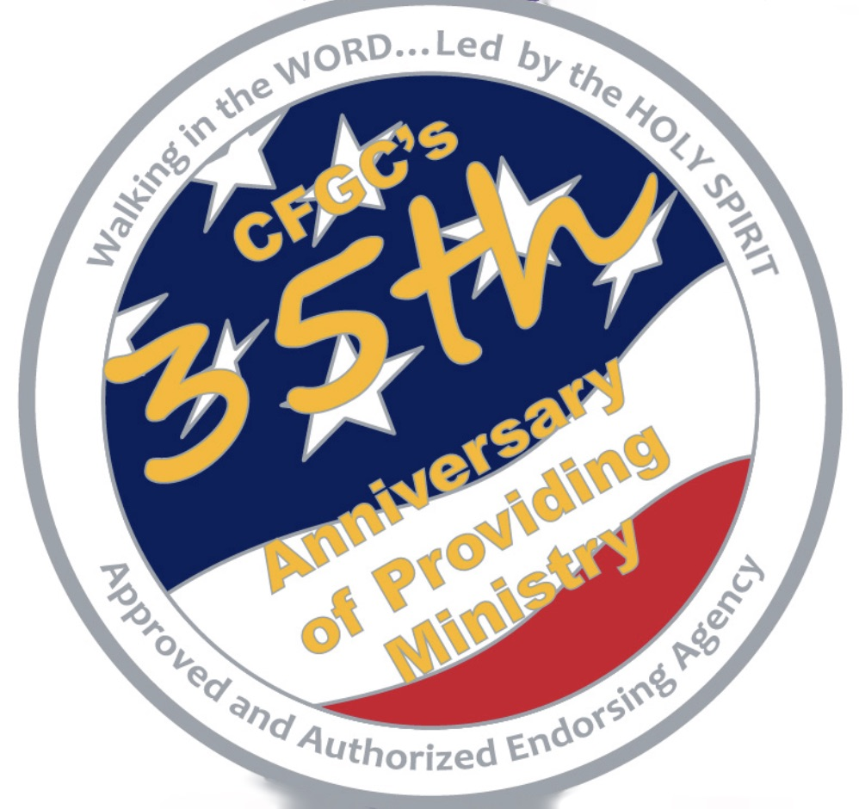
Business Meeting

9:00 AM - 1:00 PM Registration – Outside Main Ballroom

9:00 AM - 10:30 AM Prayer for the Training – CH Rhonda Harkins
_________________________________________
10:30 AM - 11:00 AM WELCOME - Praise & Worship

11:00 AM - 11:30 AM Devotion – Dr. Jack Lea
Executive Director, NCMAF

11:30 AM –11:45 PM Break

11:45 AM –12:30 PM Mike Berry, Chief of Staff, First Liberty Institute

12:30 PM - 1:30 PM Welcome Luncheon Reception & Fellowship

1:30 PM - 2:30 PM World Vision for Prayer – CH Kevin Mateer

2:30 PM - 3:00 PM BREAK

3:00 PM – 4:00 PM Spouses Fellowship - Cheryl Kitchen
3:00 PM - 4:00 PM Organizational Up-Date
Dr. Klon Kitchen, Executive Endorsing Agent
Introduce Vendors

4:00 PM – 4:15 PM NCMAF Brief - Dr. Jack Lea

4:00 PM Dinner (On your own) & FREE TIME

A prayer table will be located outside the Main Ballroom
and will be available during the entire conference
See CH Rhonda Harkins for individual times for prayer.

Wednesday, March 4

8:00 AM - 9:00 AM Continental Breakfast
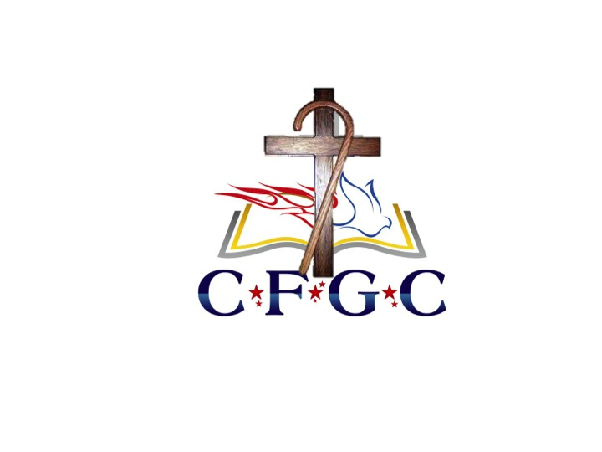
9:00 AM - 9:30 AM Praise & Worship
9:30 AM - 10:00 AM Devotion – Dr. Jack Lea

10:00 AM - 10:30 AM Break

10:30 AM - 11:15 AM Dr. John Chasteen, DMIN, PCC, CPE
Head Chaplain, Integris Hospice House,
CEO/Founder, The Chasteen Group, Coaching Consulting

11:15 AM - 11:45 AM Break

11:45 AM - 12:30 PM Dr. John Chasteen

12:30 PM - 1:30 PM Lunch

1:30 PM – 2:30 PM Dr. Jon Chasteen, President
The King’s University

4:00 PM – 5:00 PM PHOTO SESSION
(Individual/Couple & Group Chaplains W/Spouses)
Military in Formal or Class A Uniform
Civilians – Sports Coat / Suit/Dress

5:00 PM – CFGC’s 35th Anniversary Celebration Banquet
Formal or semi-formal attire please
Special Guest – CH (COL) Jim Agnew, USA, Ret.
CFGC’s 1st DOD Approved Chaplain
+ A VERY Special Guest

Presentation of the Founders Award
CH (RADM) Brent Scott

Please make your plans to attend our annual training events again at the Arlington Sheraton, Arlington, Texas

March 2 - 5, 2021 & March 1 - 4, 2022

So please join us for this spiritually uplifting
professional development training.

If you are on active duty or in a full time paid chaplain position
you MUST attend an Annual Training at least
once every three years to remain in good standing

Thursday, March 5

8:00 AM - 9:00 AM Continental Breakfast
9:00 AM - 9:30 AM Praise & Worship
9:30 AM -10:00 AM Devotion – Dr. Jack Lea

10:00 AM -10:30 AM Break
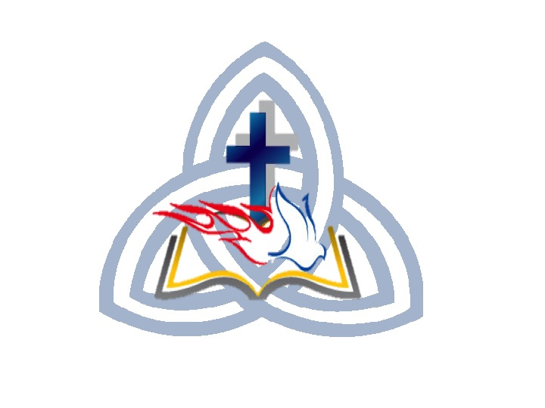
10:30 AM -11:30 AM We need Jesus – Dr. Klon Kitchen

11:30 AM –11:45 AM Break

11:45 AM –12:30 PM CH (ADM) Brent Scott

12:30 PM - 2:30 PM Ministry Breakout Lunch

Sr. Chaplain’s of each Branch will meet with their Chaplains in
assigned areas for Fellowship & Ministry Specific Updates.

US Army - CH Brian Harki / US Navy – CH Paul Tremblay
US Air Force – CH Ken Crooks / VA Chaplains- CH Kim Willis
Hospital/Healthcare Chaplains- CVH Donovan Waller
Hospice Chaplains- CH Tatum / Correctional – CH Carlos Malley
Law Enforcement/Emergency Services – CH Jim Russell
Other Civilian Chaplains – w/ CH Grant Johnson

1:15 PM – 2:30 PM Spouses Fellowship - Cheryl Kitchen

2:30 PM - 3:30 PM. Covenant Service (for those being ordained)
OTHERS REFLECTION & FREE TIME

4:30 PM - 6:00 PM Dinner (On your own)

6:00 PM - Ordination Ceremony

Time of Remembrance

Recognition of Retiring Chaplain & Families
“New Shepherd’s Association Members”

Communion Service

If you desire a Certificate of Attendance for proof of training please
contact Lucille or CH Johnson and we will issue you that Certificate

