Fri March 8
8:00 AM - 9: 00 AM Continental Breakfast
9:00 AM - 9:30 AM Praise & Worship

9:30 AM -10:00 AM Devotion – CH Melinda Ryans

10:00 AM -10:30 AM Break

10:30 AM – 10:45 AM US Secret Service Chaplain Program
Rev. Mr. Mark F. Arbeen, Program Manager

10:45 PM -11:30 PM World Vision for Prayer – CH Kevin Mateer

11:30 PM -12:30 PM Training on Ecclesiastical Standards and Expectations and Organizational Up-Date
Dr. Klon Kitchen, Executive Endorsing Agent
Grant Johnson, Associate Endorser
Lucille Singleton – Administration Director
CH. Melinda Ryans -

12:30 AM- 3:00 PM “Photo Booth Pictures”

12:30 PM - 3:00 PM Texas BBQ NEW TIME!!!!!!

5:00 PM - 7:00 PM REFLECTION GROUPS

Dr. Kitchen & CH Johnson will be available
for individual conferences (by appointments only).
(NEW Day) on Friday afternoon.

Please reserve time for meeting with them by contacting
Ms. Lucille Singleton @ 214-331-4373 or at lucille.s@cfgc-usa.com)

           A prayer table will be located outside the Main Ballroom
and will be available during the entire conference.
See CH Rhonda Harkins for individual times for prayer.

** Chaplain Candidate’s & Civilian Chaplains please set a time
with CH Johnson if needing one-on-one time.

*** Those with administrative issues, see Ms. Lucille Singleton.
2019 CFGC Ecclesiastical
Re-certification & Training
March 5 – 8, 2019
(Schedule subject to change)

If you desire a Certificate of Attendance for proof of training please
contact Lucille or CH Johnson and we will issue you that Certificate

PLEASE RETURN NAME BADGES AT THE END OF OUR TRAINING FOR FUTURE USE. Thank You!

Tues March 5

9:00 AM - 10:30 AM Board of Directors & Chaplains Council
Business Meeting

9:00 AM - 1:00 PM Registration – Outside Main Ballroom

9:00 AM - 10:30 AM Prayer for the Training – CH Rhonda Harkins

10:30 AM - 11:00 AM WELCOME - Praise & Worship

11:00 AM - 11:30 AM Devotion – CH Grant Johnson

11:30 AM –11:45 PM Break

11:45 AM –12:30 PM Dr. Len Sweet

12:30 PM - 1:30 PM Welcome Luncheon Reception & Fellowship

1:45 PM - 2:30 PM Dr. Len Sweet

2:30 PM – 3:00 PM BREAK

3:00 PM – 4:00 PM Dr. Len Sweet

4:30 PM Dinner (On your own) & FREE TIME

7:00 PM - Movie screening of The Mully Movie (Optional)

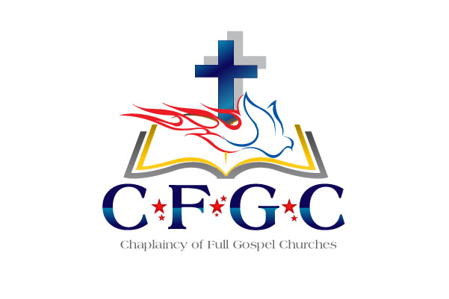

Wed March 6

8:00 AM - 9:00 AM Continental Breakfast
9:00 AM - 9:30 AM Praise & Worship
9:30 AM - 10:00 AM Devotion – Dr. Klon Kitchen

10:00 AM - 10:30 AM Break

10:30 AM - 11:15 AM Dr. Len Sweet

11:15 AM - 11:45 AM Break

11:45 AM - 12:30 PM Dr. Len Sweet

12:30 PM - 2:30 PM Lunch

2:30 PM - 4:00 PM Sr. Chaplain’s of each Branch will meet with
their Chaplains In assigned areas for Fellowship & Branch Specific h.

US Army - CH David Waters / US Navy – CH Paul Tremblay
US Air Force – CH Ken Crooks / VA Chaplains- CH Matt Cassidy
Hospital Chaplains- CH Angela Niestemski / Hospice Chaplains- CH Tatum
Emergency Services – CH Jim Russell / Correctional – CH Antoine Barlow
Other Civilian Chaplains –w/ CH Grant Johnson

1:30 PM – 4:30 PM Spouses Fellowship - Cheryl Kitchen

4:30 PM - REFLECTION & FREE TIME

Please make your plans to attend our annual training events again at the Arlington Sheraton, Arlington, Texas.

MARCH 2 - 6, 2020

So please join us for this spiritually uplifting professional development training.

If you are on active duty or in a full time paid chaplain position you MUST attend an Annual Training
at least once every three years to remain in good standing.

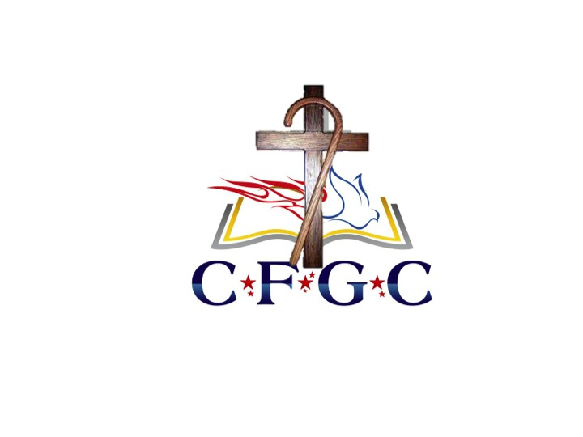

Thurs March 7

8:00 AM - 9:00 AM Continental Breakfast
9:00 AM - 9:30 AM Praise & Worship
9:30 AM -10:00 AM Devotion – CH Rhonda Harkins

10:00 AM -11:00 AM A Time of Prayer

11:00 AM -11:30 AM Break

11:30 AM–12:45 PM CH (ADM) Brent Scott

12:45 PM - 2:30 PM LUNCH

2:30 PM - 3:30 PM Covenant Service for those being ordained.

+ REFLECTION & FREE TIME

4:30 PM - 5:30 PM Dinner (On your own)

5:30 PM -6:30 PM PHOTO SESSION
(Individual/Couple & Group Chaplains W/Spouses)
Military in Class A Uniform
Civilians – Sports Coat / Suit/Dress

6:30 PM – 8:30 PM

Recognition of Retiring Chaplain & Families

“The Shepherd’s Association”

Time of Remembrance

Presentation of the Founders Award
CH Ernest “Skip” Dalle Molle

Ordination Ceremony

Communion Service

